**Assignment 1 (ADC specs )**

**ADC Selection Criteria**

**Specifications:**

* Resolution: 12 bits
* Sample rate: ≥ 1 MSps
* Channels: 1
* Input type: Differential
* Maximum DNL: < 1 LSB
* Maximum INL: < 1 LSB
* Minimize power consumption

|  |  |  |  |
| --- | --- | --- | --- |
| SPEC | **ADI AD9613** | **TI ADC12C105** | **Research ADC** |
| **Price** | Starting from $49.43 | Starting from $25.555 | Not specified |
| **Min Power Supply (V)** | 1.8 V | 3 ,3.3 V | 0.8 V |
| **Architecture** | PIPELINED | PIPELINED | Successive Approximation Register (SAR) |
| **Peak-to-Peak Input Range (V)** | 1.4 V p-p to 2.0 V p-p (1.75 V p-p nominal) | 2 V p-p | 0.8 Vp-p |
| **Power consumption** | 3.08 mW | 3.3 mW | 0.78 mW |
| **MAX DNL (LSB)** | 0.5 LSB | ±0.5 LSB | +0.6/-0.4LSB |
| **Max INL (LSB)** | 1 LSB | ±1.0 LSB | +0.9/-0.8LSB |
| **ENOB(bits)** | Approximately 11.3 bits at 250 MSps | Approximately 11.5 bits at 105 MSps | 9.9 bits |
| **SNR(dB)** | 69.6 dBFS at 185 MHz input and 250 MSps | 69 dBFS at 240 MSps | |  | | --- | |  |   61.5 dB |
| **SINAD(dB)** | 60 dB | 70 dB | 61.3 dB |
| **SFDR(dB)** | 86 dBc at 185 MHz input and 250 MSps | 82 dBFS at 240 MHz input | 82 dB |
| **Digital Output Format** | LVDS (ANSI-644 levels) | Parallel CMOS | Serial |
| **Internal Reference** | Yes | Yes | NO |
| **Internal Sampling Clock** | NO | NO | NO |
| **Walden FoM (fJ/step)** | ​≈1.45 fJ/step | 4.19 fJ/step | 8.2 fJ/step |
| **Schreier FoM (dB)** | 137 dB | 146.8 dB | 169.2dB |

BLOCK DIAGRAM FOR **ADI AD9613 :**

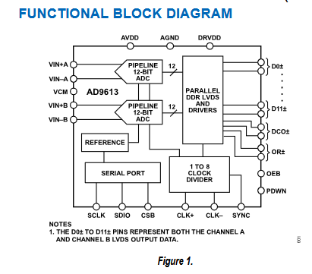

BLOCK DIAGRAM FOR **TI ADC12C105 :**

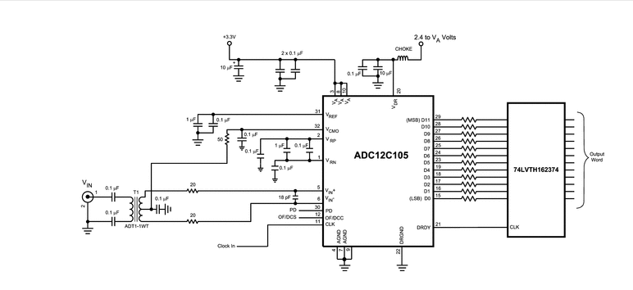

BLOCK DIAGRAM FOR **SAR ADC:**

**“A 12-bit 100MS/s SAR ADC With EquivalentSplit-Capacitor and LSB-Averaging in 14-nm CMOS FinFET”**

[**https://www.researchgate.net/publication/357005765_A_12-bit_100MSs_SAR_ADC_With_Equivalent_Split-Capacitor_and_LSB-Averaging_in_14-nm_CMOS_FinFET**](https://www.researchgate.net/publication/357005765_A_12-bit_100MSs_SAR_ADC_With_Equivalent_Split-Capacitor_and_LSB-Averaging_in_14-nm_CMOS_FinFET)

